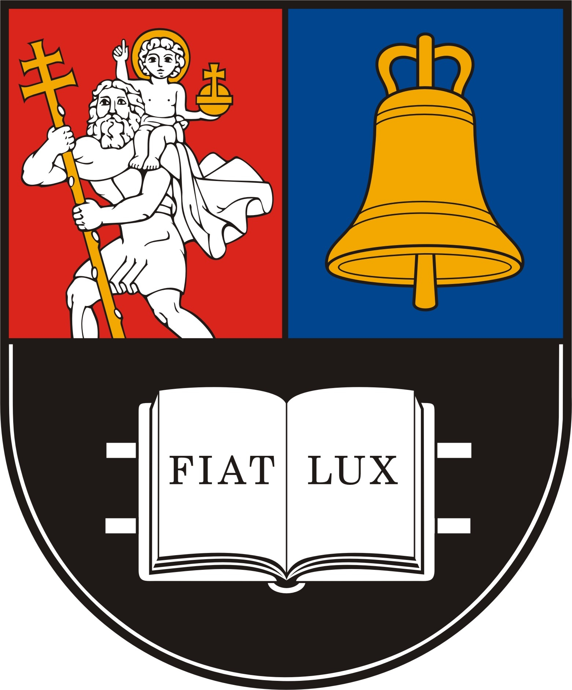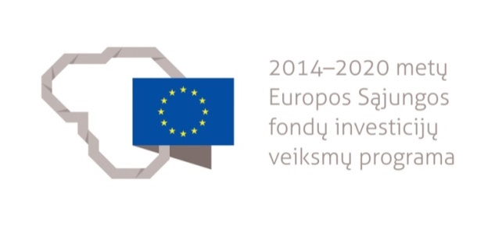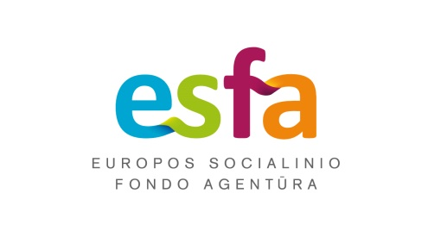

REGISTRATION FORM OF THE EDUCATIONAL CAMP TO LEARN
THE LITHUANIAN LANGUAGE, CULTURE AND HISTORY
(ORGANISED BY LITHUANIAN UNIVERSITY OF EDUCATIONAL SCIENCES)

The centre for Baltic studies the student comes from:

Data about the incoming student:

Surname:
Name:
Date of birth:
Citizenship:
Gender:
The year of studies of the incoming student at the Baltic centre:
Proficiency of Lithuanian according to CEFR:
A1 A2
B1 B2
C1 C2
E-mail address:
Telephone:

Special requirements:

Head of the centre for Baltic studies submitting application
name, surname, signature

The educational camp is organised in the framework of the project “Lithuanian Academic Scheme for International Cooperation in Baltic Studies” (No. 09.3.1-ESFA- V-709- 01-0002).
